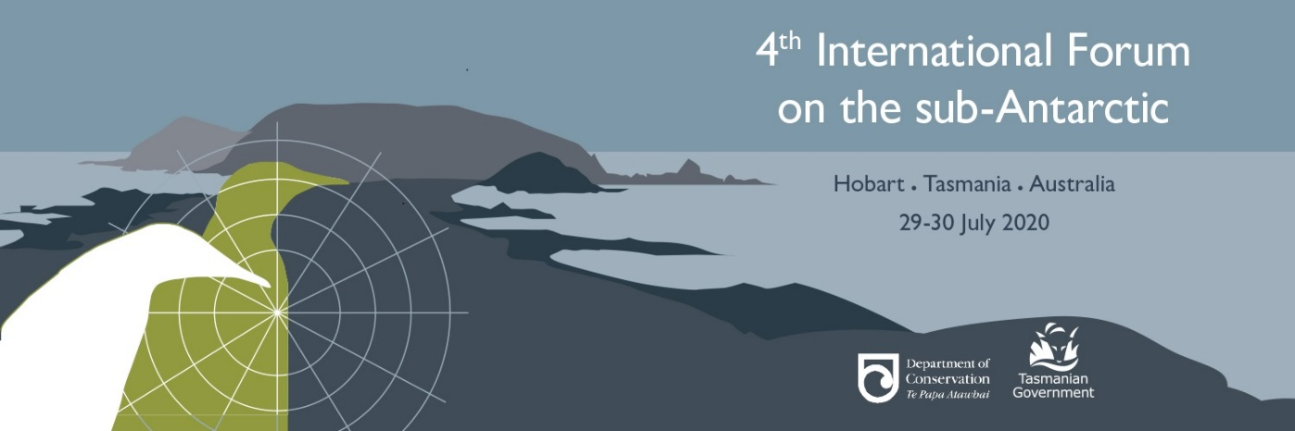

Travel Assistance Fund
The Forum hosts want to encourage delegates from as many countries and organisations as possible to attend the Forum in July 2020.
Through generous support from Serco Asia Pacific, operators of Australia’s new icebreaker Nuyina, and the Forum hosts we are able to provide a limited travel assistance program to support delegates coming from outside Australia who would otherwise have difficulty in attending.
The travel assistance is intended to off-set a proportion of travel (to/from Hobart) and Hobart accommodation expenses for Forum delegates.
What funding is available?
Funding is limited and we may not be able to support all applications. The fund will not cover the full cost of attending.
The assistance provided will be based on:
- distance from, and cost of travel to Hobart
- need
- information provided in the application form.
- the amount of funds available

How will the funds be paid?
The travel assistance granted will be paid as a one –off amount, not by reimbursement of specific costs.
Payment will be made after attendance at the Forum, unless specific arrangements are agreed due to the financial circumstances related to geographic or financial matters. Recipients will be required to provide proof of expenditure to at least the level of the assistance provided (for example boarding passes, accommodation check-out receipt, credit card or bank statement).

Who is eligible?
Applications will be considered from all potential delegates coming from outside Australia, but preference will be given to applicants who do not have access to other funds to support their travel.
Abstract submitters will have priority consideration.
Delegates must attend the Forum. If for some reason the delegate is unable to attend, any travel assistance already received must be repaid so that it is available to assist others.

What is the application process?
Applicants for travel assistance must complete an application form, available on the website www.subantarcticforum.tas.gov.au .

Closing Date
Applications must be submitted via email to: info@subantarcticforum.tas.gov.au by 5 pm, 29 February 2020 AEST.

Selection of successful applicants.
Not all applicants will be successful. The steering committee will evaluate applications based on the information provided. Successful applicants will be notified as soon as possible after the closing date, but certainly by 31 March 2020.

