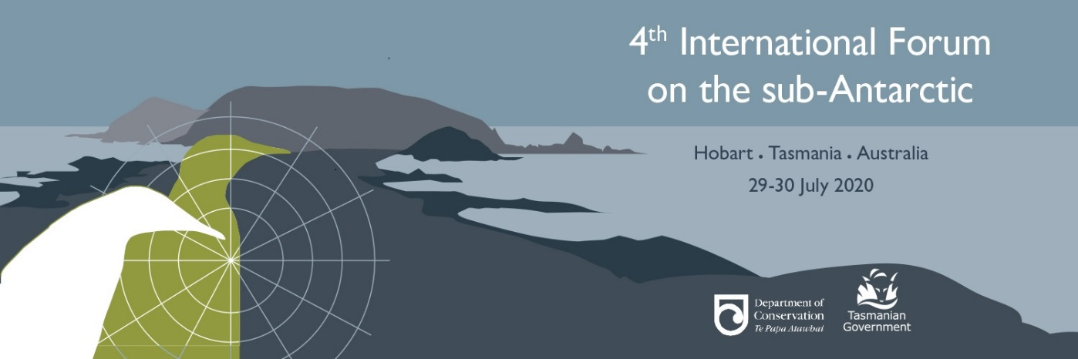
Travel Assistance Fund Application Form
Application deadline: 29 February 2020, 5pm AEST.
Please read the guidelines before completing the application form. Please answer all the questions or your application won’t be considered.
Applicant details:
- Name: Click here to enter text.
- Email Address: Click here to enter text.
- Institution/Employer: Click here to enter text.
- Position at institution/organisation: Click here to enter text.
- Usual place of residence: Click here to enter text.
- Place you will be travelling from (if different to above, and reason why this is different): Click here to enter text.
- Planned role at forum – (speaker/panel member/poster presenter/delegate): Click here to enter text.
- Have you submitted an Abstract? (Abstract submitters will have priority consideration): Click here to enter text.
- Abstract Title: Click here to enter text.
Budget:
Please provide costs in AUD
- Estimated cost of:
  - Travel: $Click here to enter text.
  - Accommodation: $Click here to enter text.
  - Other costs: $Click here to enter text.
  - Total costs: $Click here to enter text.
- Funding to be contributed from other sources: $Click here to enter text.
- Amount of assistance requested $ Click here to enter text.

Supporting Information:
- In 100 words or less, please explain how your work and service has contributed to understanding of the sub-Antarctic

- In 100 words or less, please explain the expected benefits of attending the Forum.

- In 100 words or less, explain why you, your organisation or your university is unable, or has limited ability, to cover the travel costs of attending the 4th International sub-Antarctic Forum.

Please submit your application online via email to: info@subAntarcticForum.tas.gov.au by 5 pm, 29 February 2020 AEST.

Checklist
Have you:
☐ ensured your application fits the guidelines?
☐ completed all sections including the supporting information?
☐ provided an accurate budget?
☐ taken a copy of your application for your records?
☐ ensured that your application is submitted by 5 pm, 29 February 2020, AEST?

